UNITED STATES
SECURITIES AND EXCHANGE COMMISSION
Washington, D.C. 20549

SCHEDULE TO
Tender Offer Statement under Section 14(d)(1) or 13(e)(1)
of the Securities Exchange Act of 1934

Alpine Immune Sciences, Inc.
(Name of Subject Company (issuer))
Adams Merger Sub, Inc.
(Offeror)
a wholly-owned subsidiary of
Vertex Pharmaceuticals Incorporated
(Parent of Offeror)
(Names of Filing Persons (identifying status as offeror, issuer or other person))

Common stock, $0.01 par value per share
(Title of Class of Securities)
92532F100
(CUSIP Number of Class of Securities)
Jonathan Biller
Executive Vice President, Chief Legal Officer
Vertex Pharmaceuticals Incorporated
50 Northern Avenue
Boston, Massachusetts 02210
Telephone: (617) 341-6100
(Name, address, and telephone numbers of person authorized to receive notices and communications on behalf of filing persons)

Copy to:

Graham Robinson  Skadden, Arps, Slate, Meagher & Flom LLP  500 Boylston Street  Boston, MA 02116  (617) 573-4850 |  | Faiz Ahmad  Skadden, Arps, Slate, Meagher & Flom LLP  1 Rodney Square, P.O. Box 636  Wilmington, DE 19899  (302) 651-3250

CALCULATION OF FILING FEE

Transaction Valuation* |  | Amount of Filing Fee*
N/A |  | N/A
* | A filing fee is not required in connection with this filing as it relates solely to preliminary communications made before the commencement of the tender offer.

☒ | Check the box if the filing relates solely to preliminary communications made before the commencement of a tender offer.
Check the appropriate boxes below to designate any transactions to which the statement relates:

☒ | Third-party tender offer subject to Rule 14d-1.
☐ | Going-private transaction subject to Rule 13e-3.
☐ | Issuer tender offer subject to Rule 13e-4.
☐ | Amendment to Schedule 13D under Rule 13d-2.
Check the following box if the filing is a final amendment reporting the results of the tender offer: ☐
If applicable, check the appropriate box(es) below to designate the appropriate rule provision(s) relied upon:

☐ | Rule 13e-4(i) (Cross-Border Issuer Tender Offer).
☐ | Rule 14d-1(d) (Cross-Border Third-Party Tender Offer).

This Tender Offer Statement on Schedule TO relates solely to preliminary communications made before the commencement of a planned tender offer by Adams Merger Sub, Inc., a Delaware corporation (Merger Sub) and wholly-owned subsidiary of Vertex Pharmaceuticals Incorporated, a Massachusetts corporation (Parent), for all of the outstanding shares of common stock of Alpine Immune Sciences, Inc., a Delaware corporation (the Company), pursuant to the Agreement and Plan of Merger, dated as of April 10, 2024 (the Merger Agreement), among Parent, Merger Sub and the Company.
Additional Information and Where to Find It
The tender offer for the outstanding shares of common stock of the Company referenced in this communication has not yet commenced. This communication is for informational purposes only and is neither an offer to purchase nor a solicitation of an offer to sell shares of the Company, nor is it a substitute for any tender offer materials that Parent or the Company will file with the Securities and Exchange Commission (SEC). At the time the tender offer is commenced, Parent will file with the SEC a Tender Offer Statement on Schedule TO which will include an Offer to Purchase, a related Letter of Transmittal and certain other tender offer documents (together, the Tender Offer Materials), and the Company will file with the SEC a Solicitation/Recommendation Statement on Schedule 14D-9 (the Solicitation/Recommendation Statement) with respect to the tender offer. THE COMPANYS SECURITY HOLDERS ARE URGED TO READ THE TENDER OFFER MATERIALS AND THE SOLICITATION/RECOMMENDATION STATEMENT WHEN THEY BECOME AVAILABLE BECAUSE THEY WILL CONTAIN IMPORTANT INFORMATION WHICH SHOULD BE READ CAREFULLY BEFORE ANY DECISION IS MADE WITH RESPECT TO THE TENDER OFFER. The Tender Offer Materials, as well as the Solicitation/Recommendation Statement, will be sent to all stockholders of the Company at no expense to them. The Tender Offer Materials and the Solicitation/Recommendation Statement will be made available for free at the SECs website at www.sec.gov. Additional copies may be obtained free of charge under the Investors section of Parents website at https://investors.vrtx.com/financial-information/sec-filings or by contacting Parent by email at Investorinfo@VRTX.com, or by directing requests for such materials to the information agent for the offer, which will be named in the Tender Offer Materials. In addition to the Tender Offer Materials and the Solicitation/Recommendation Statement, the Company and Vertex file periodic reports and other information with the SEC. Parents and the Companys filings with the SEC are also available for free to the public from commercial document-retrieval services and at the website maintained by the SEC at www.sec.gov and their respective investor relations websites at the addresses above.
Cautionary Statement Regarding Forward-Looking Statements
This communication contains forward-looking statements related to Parent, the Company and the proposed acquisition of the Company by Parent (the Transaction) that are subject to risks, uncertainties and other factors. While Parent believes the forward-looking statements contained in this communication are accurate, these forward-looking statements represent Parents belief only as of the date of this communication, and there are a number of risks and uncertainties that could cause actual events or results to differ materially from those expressed or implied by such forward-looking statements. All statements other than statements of historical fact are statements that could be deemed forward-looking statements, including all statements regarding the intent, belief or current expectation of the companies and members of their senior management teams. Forward-looking statements are not purely historical and may be accompanied by words such as anticipates, may, forecasts, expects, intends, plans, potentially, believes, seeks, estimates, and other words and terms of similar meaning. Such statements may relate to: the ability of Parent to advance the Companys platform technology and potential therapies, such as povetacicept, on a timely basis; filings and approvals relating to the Transaction; the expected timing of the completion of the Transaction; the ability to complete the Transaction considering the various closing conditions; difficulties or unanticipated expenses in connection with integrating the companies; and any assumptions underlying any of the foregoing.
Forward-looking statements are subject to certain risks, uncertainties, or other factors that are difficult to predict and could cause actual events or results to differ materially from those indicated in any such statements due to a number of risks and uncertainties. Those risks and uncertainties that could cause the actual results to differ from expectations contemplated by forward-looking statements include, among other things: uncertainties as to the timing of the Transaction; uncertainties as to how many of the Companys stockholders will tender their stock in the offer; the

possibility that competing offers will be made; the possibility that various closing conditions for the Transaction may not be satisfied or waived, including that a governmental entity may prohibit, delay or refuse to grant approval for the consummation of the Transaction; the effects of the Transaction on relationships with employees, other business partners or governmental entities; the difficulty of predicting the timing or outcome of FDA approvals or actions, if any; the impact of competitive products and pricing; that Parent may not realize the potential benefits of the Transaction; other business effects, including the effects of industry, economic or political conditions outside of the companies control; Transaction costs; and actual or contingent liabilities related to the Transaction. In addition, the product candidates being developed by the Company are subject to all the risks inherent in the drug development process, and there can be no assurance that the development of these product candidates will be commercially successful. Forward-looking statements in this communication should be evaluated tother with the many uncertainties that affect Parents and the Companys businesses, particularly those risks listed under the heading Risk Factors and the other cautionary factors discussed in the parties periodic reports filed with the SEC, including Parents annual report on Form 10-K for the year ended December 31, 2023, and its quarterly reports on Form 10-Q and current reports on Form 8-K, and the Companys annual report on Form 10-K for the year ended December 31, 2023, and its quarterly reports on Form 10-Q and current reports on Form 8-K, as well as the Solicitation/Recommendation Statement to be filed by the Company and the Tender Offer Materials to be filed by Parent and Merger Sub, a direct wholly owned subsidiary of Parent, all of which are available, or will be available when filed, for free on the SECs website at www.sec.gov. You should not place undue reliance on these statements. All forward-looking statements are based on information currently available to Parent, and Parent disclaims any obligation to update the information contained in this communication as new information becomes available, except as required by law.
Item 12. Exhibits

Exhibit No. |  | Description
Exhibit 99.1 |  | Joint Press Release issued on April 10, 2024 (incorporated herein by reference to Exhibit 99.1 of the Current Report on Form 8-K filed by Alpine Immune Sciences, Inc. with the SEC on April 10, 2024).
Exhibit 99.2 |  | Investor Presentation, dated April 10, 2024.
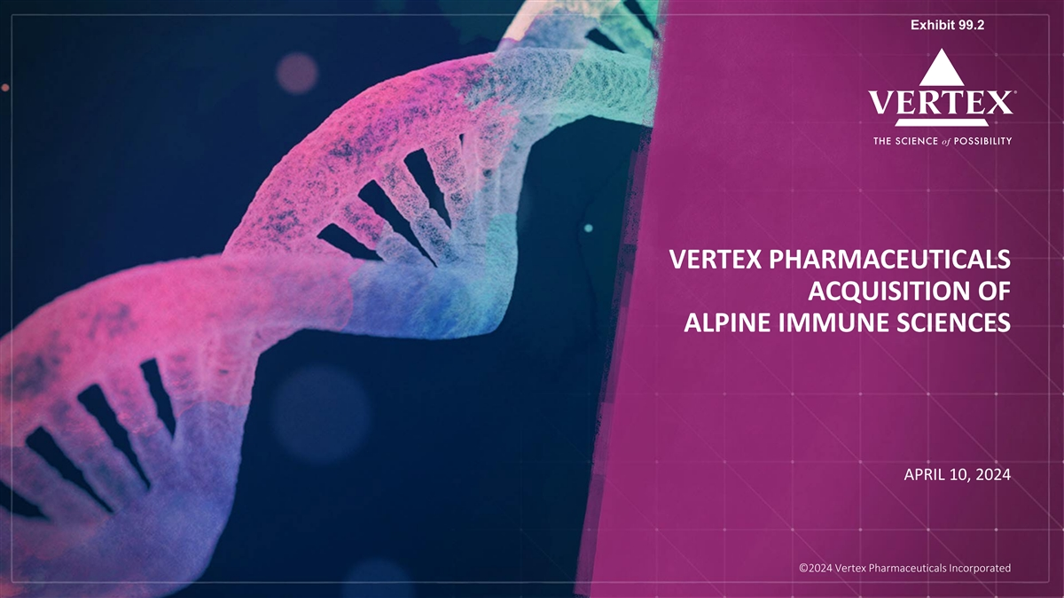
Exhibit 99.2 VERTEX PHARMACEUTICALS ACQUISITION OF ALPINE IMMUNE SCIENCES APRIL 10, 2024 ©2024 Vertex Phag rlm oba acle .v uti rtx c.a clo s m Incorporated

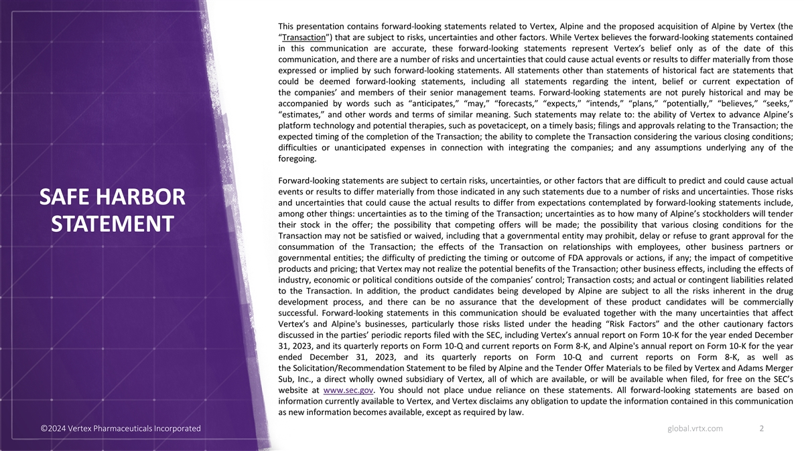
This presentation contains forward-looking statements related to Vertex, Alpine and the proposed acquisition of Alpine by Vertex (the “Transaction”) that are subject to risks, uncertainties and other factors. While Vertex believes the forward-looking statements contained in this communication are accurate, these forward-looking statements represent Vertex’s belief only as of the date of this communication, and there are a number of risks and uncertainties that could cause actual events or results to differ materially from those expressed or implied by such forward-looking statements. All statements other than statements of historical fact are statements that could be deemed forward-looking statements, including all statements regarding the intent, belief or current expectation of the companies’ and members of their senior management teams. Forward-looking statements are not purely historical and may be accompanied by words such as “anticipates,” “may,” “forecasts,” “expects,” “intends,” “plans,” “potentially,” “believes,” “seeks,” “estimates,” and other words and terms of similar meaning. Such statements may relate to: the ability of Vertex to advance Alpine’s platform technology and potential therapies, such as povetacicept, on a timely basis; filings and approvals relating to the Transaction; the expected timing of the completion of the Transaction; the ability to complete the Transaction considering the various closing conditions; difficulties or unanticipated expenses in connection with integrating the companies; and any assumptions underlying any of the foregoing. Forward-looking statements are subject to certain risks, uncertainties, or other factors that are difficult to predict and could cause actual events or results to differ materially from those indicated in any such statements due to a number of risks and uncertainties. Those risks SAFE HARBOR and uncertainties that could cause the actual results to differ from expectations contemplated by forward-looking statements include, among other things: uncertainties as to the timing of the Transaction; uncertainties as to how many of Alpine’s stockholders will tender their stock in the offer; the possibility that competing offers will be made; the possibility that various closing conditions for the STATEMENT Transaction may not be satisfied or waived, including that a governmental entity may prohibit, delay or refuse to grant approval for the consummation of the Transaction; the effects of the Transaction on relationships with employees, other business partners or governmental entities; the difficulty of predicting the timing or outcome of FDA approvals or actions, if any; the impact of competitive products and pricing; that Vertex may not realize the potential benefits of the Transaction; other business effects, including the effects of industry, economic or political conditions outside of the companies’ control; Transaction costs; and actual or contingent liabilities related to the Transaction. In addition, the product candidates being developed by Alpine are subject to all the risks inherent in the drug development process, and there can be no assurance that the development of these product candidates will be commercially successful. Forward-looking statements in this communication should be evaluated together with the many uncertainties that affect Vertex’s and Alpine's businesses, particularly those risks listed under the heading “Risk Factors” and the other cautionary factors discussed in the parties’ periodic reports filed with the SEC, including Vertex’s annual report on Form 10-K for the year ended December 31, 2023, and its quarterly reports on Form 10-Q and current reports on Form 8-K, and Alpine's annual report on Form 10-K for the year ended December 31, 2023, and its quarterly reports on Form 10-Q and current reports on Form 8-K, as well as the Solicitation/Recommendation Statement to be filed by Alpine and the Tender Offer Materials to be filed by Vertex and Adams Merger Sub, Inc., a direct wholly owned subsidiary of Vertex, all of which are available, or will be available when filed, for free on the SEC’s website at www.sec.gov. You should not place undue reliance on these statements. All forward-looking statements are based on information currently available to Vertex, and Vertex disclaims any obligation to update the information contained in this communication as new information becomes available, except as required by law. ©2024 Vertex Pharmaceuticals Incorporated global.vrtx.com 2

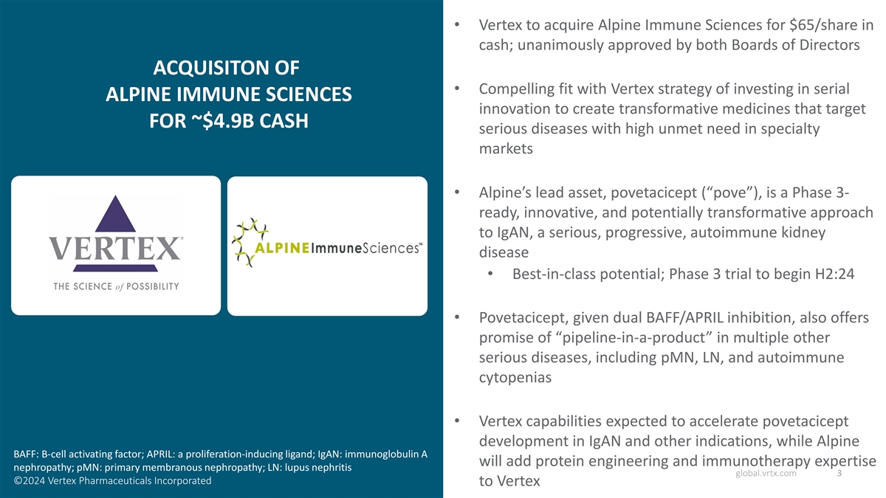
• Vertex to acquire Alpine Immune Sciences for $65/share in cash; unanimously approved by both Boards of Directors ACQUISITON OF • Compelling fit with Vertex strategy of investing in serial ALPINE IMMUNE SCIENCES innovation to create transformative medicines that target FOR ~$4.9B CASH serious diseases with high unmet need in specialty markets • Alpine’s lead asset, povetacicept (“pove”), is a Phase 3- ready, innovative, and potentially transformative approach to IgAN, a serious, progressive, autoimmune kidney disease • Best-in-class potential; Phase 3 trial to begin H2:24 • Povetacicept, given dual BAFF/APRIL inhibition, also offers promise of “pipeline-in-a-product” in multiple other serious diseases, including pMN, LN, and autoimmune cytopenias • Vertex capabilities expected to accelerate povetacicept development in IgAN and other indications, while Alpine BAFF: B-cell activating factor; APRIL: a proliferation-inducing ligand; IgAN: immunoglobulin A will add protein engineering and immunotherapy expertise nephropathy; pMN: primary membranous nephropathy; LN: lupus nephritis global.vrtx.com 3 ©2024 Vertex Pharmaceuticals Incorporated to Vertex

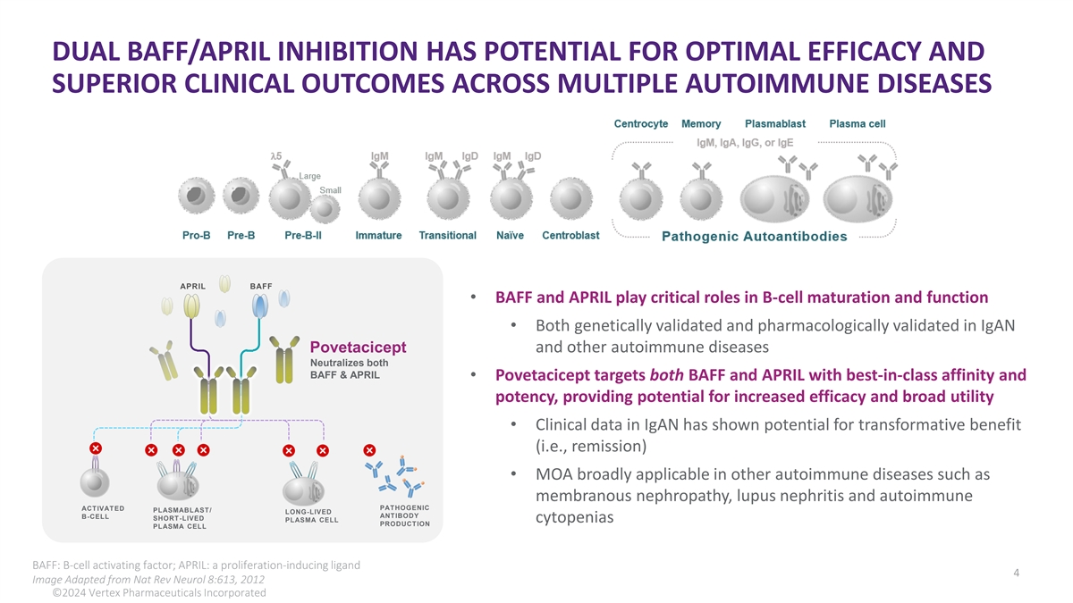
DUAL BAFF/APRIL INHIBITION HAS POTENTIAL FOR OPTIMAL EFFICACY AND SUPERIOR CLINICAL OUTCOMES ACROSS MULTIPLE AUTOIMMUNE DISEASES APRIL BAFF • BAFF and APRIL play critical roles in B-cell maturation and function • Both genetically validated and pharmacologically validated in IgAN Povetacicept and other autoimmune diseases Neutralizes both BAFF & APRIL • Povetacicept targets both BAFF and APRIL with best-in-class affinity and potency, providing potential for increased efficacy and broad utility • Clinical data in IgAN has shown potential for transformative benefit (i.e., remission) • MOA broadly applicable in other autoimmune diseases such as membranous nephropathy, lupus nephritis and autoimmune PATHOGENIC ACTIVATED PLASMABLAST/ LONG-LIVED ANTIBODY B-CELL SHORT-LIVED PLASMA CELL cytopenias PRODUCTION PLASMA CELL BAFF: B-cell activating factor; APRIL: a proliferation-inducing ligand global.vrtx.com 4 Image Adapted from Nat Rev Neurol 8:613, 2012 ©2024 Vertex Pharmaceuticals Incorporated

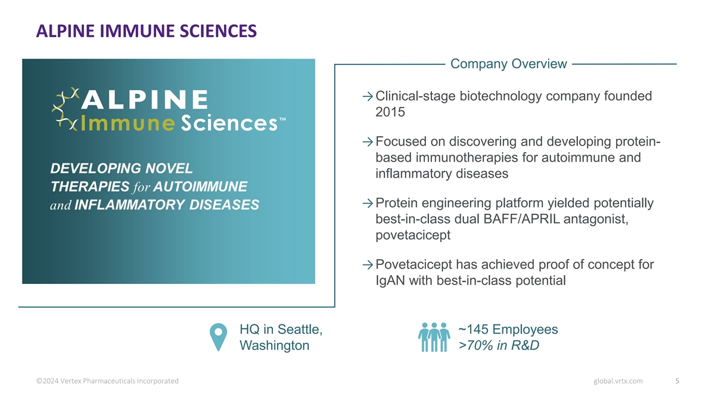
ALPINE IMMUNE SCIENCES Company Overview →Clinical-stage biotechnology company founded 2015 →Focused on discovering and developing protein- based immunotherapies for autoimmune and inflammatory diseases →Protein engineering platform yielded potentially best-in-class dual BAFF/APRIL antagonist, povetacicept →Povetacicept has achieved proof of concept for IgAN with best-in-class potential HQ in Seattle, ~145 Employees Washington >70% in R&D ©2024 Vertex Pharmaceuticals Incorporated global.vrtx.com 5

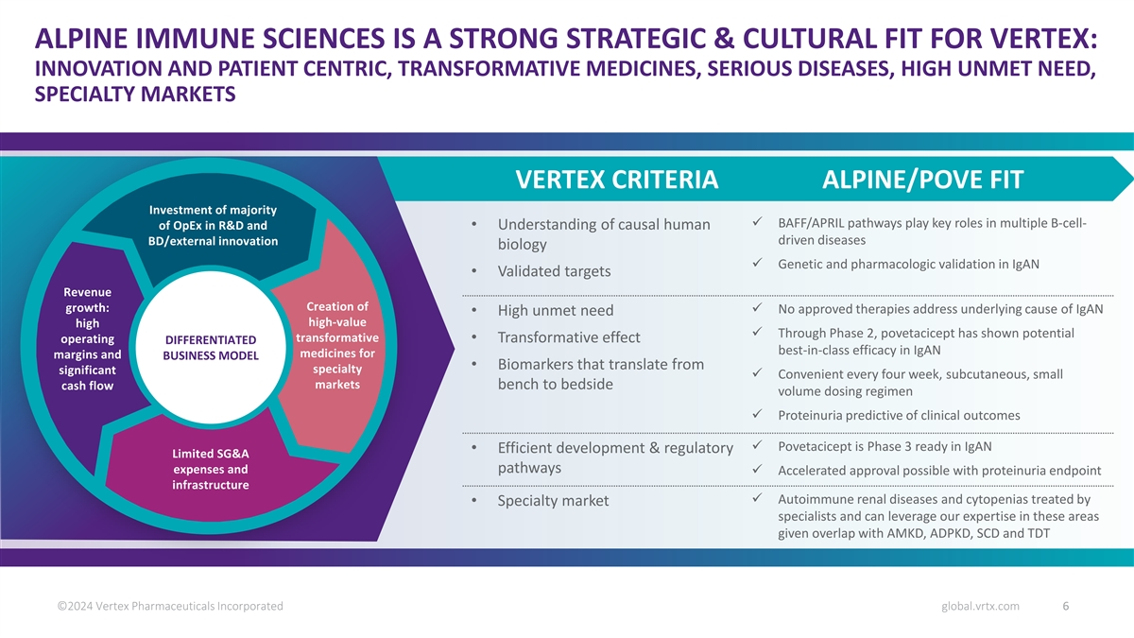
ALPINE IMMUNE SCIENCES IS A STRONG STRATEGIC & CULTURAL FIT FOR VERTEX: INNOVATION AND PATIENT CENTRIC, TRANSFORMATIVE MEDICINES, SERIOUS DISEASES, HIGH UNMET NEED, SPECIALTY MARKETS VERTEX CRITERIA ALPINE/POVE FIT Investment of majority ü BAFF/APRIL pathways play key roles in multiple B-cell- of OpEx in R&D and • Understanding of causal human driven diseases BD/external innovation biology ü Genetic and pharmacologic validation in IgAN • Validated targets Revenue Creation of growth: ü No approved therapies address underlying cause of IgAN • High unmet need high-value high ü Through Phase 2, povetacicept has shown potential transformative operating • Transformative effect DIFFERENTIATED best-in-class efficacy in IgAN medicines for margins and BUSINESS MODEL • Biomarkers that translate from specialty significant ü Convenient every four week, subcutaneous, small markets cash flow bench to bedside volume dosing regimen ü Proteinuria predictive of clinical outcomes ü Povetacicept is Phase 3 ready in IgAN • Efficient development & regulatory Limited SG&A pathways expenses and ü Accelerated approval possible with proteinuria endpoint infrastructure ü Autoimmune renal diseases and cytopenias treated by • Specialty market specialists and can leverage our expertise in these areas given overlap with AMKD, ADPKD, SCD and TDT ©2024 Vertex Pharmaceuticals Incorporated global.vrtx.com 6

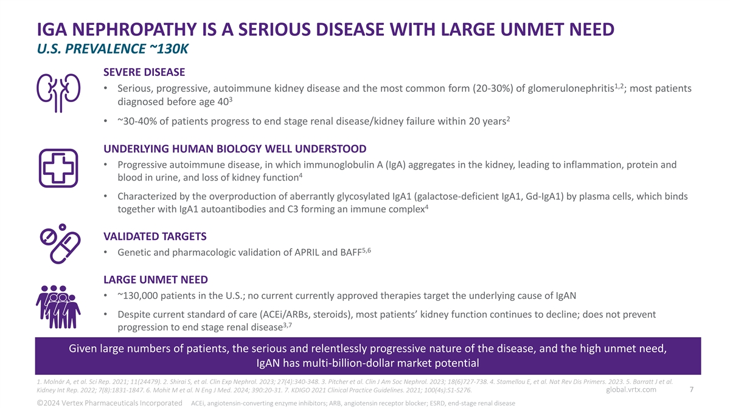
IGA NEPHROPATHY IS A SERIOUS DISEASE WITH LARGE UNMET NEED U.S. PREVALENCE ~130K SEVERE DISEASE 1,2 • Serious, progressive, autoimmune kidney disease and the most common form (20-30%) of glomerulonephritis ; most patients 3 diagnosed before age 40 2 • ~30-40% of patients progress to end stage renal disease/kidney failure within 20 years UNDERLYING HUMAN BIOLOGY WELL UNDERSTOOD • Progressive autoimmune disease, in which immunoglobulin A (IgA) aggregates in the kidney, leading to inflammation, protein and 4 blood in urine, and loss of kidney function • Characterized by the overproduction of aberrantly glycosylated IgA1 (galactose-deficient IgA1, Gd-IgA1) by plasma cells, which binds 4 together with IgA1 autoantibodies and C3 forming an immune complex VALIDATED TARGETS 5,6 • Genetic and pharmacologic validation of APRIL and BAFF LARGE UNMET NEED • ~130,000 patients in the U.S.; no current currently approved therapies target the underlying cause of IgAN • Despite current standard of care (ACEi/ARBs, steroids), most patients’ kidney function continues to decline; does not prevent 3,7 progression to end stage renal disease Given large numbers of patients, the serious and relentlessly progressive nature of the disease, and the high unmet need, IgAN has multi-billion-dollar market potential 1. Molnár A, et al. Sci Rep. 2021; 11(24479). 2. Shirai S, et al. Clin Exp Nephrol. 2023; 27(4):340-348. 3. Pitcher et al. Clin J Am Soc Nephrol. 2023; 18(6)727-738. 4. Stamellou E, et al. Nat Rev Dis Primers. 2023. 5. Barratt J et al. global.vrtx.com 7 Kidney Int Rep. 2022; 7(8):1831-1847. 6. Mohit M et al. N Eng J Med. 2024; 390:20-31. 7. KDIGO 2021 Clinical Practice Guidelines. 2021; 100(4s):S1-S276. ©2024 Vertex Pharmaceuticals Incorporated ACEi, angiotensin-converting enzyme inhibitors; ARB, angiotensin receptor blocker; ESRD, end-stage renal disease

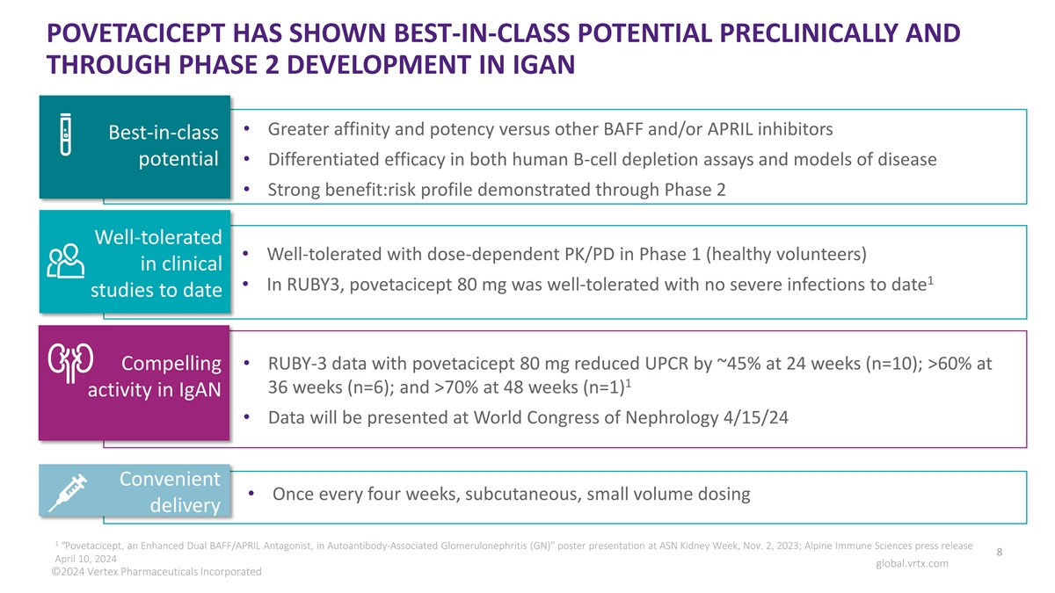
POVETACICEPT HAS SHOWN BEST-IN-CLASS POTENTIAL PRECLINICALLY AND THROUGH PHASE 2 DEVELOPMENT IN IGAN • Greater affinity and potency versus other BAFF and/or APRIL inhibitors Best-in-class potential • Differentiated efficacy in both human B-cell depletion assays and models of disease • Strong benefit:risk profile demonstrated through Phase 2 Well-tolerated • Well-tolerated with dose-dependent PK/PD in Phase 1 (healthy volunteers) in clinical 1 • In RUBY3, povetacicept 80 mg was well-tolerated with no severe infections to date studies to date Compelling • RUBY-3 data with povetacicept 80 mg reduced UPCR by ~45% at 24 weeks (n=10); >60% at 1 36 weeks (n=6); and >70% at 48 weeks (n=1) activity in IgAN • Data will be presented at World Congress of Nephrology 4/15/24 Convenient • Once every four weeks, subcutaneous, small volume dosing delivery 1 “Povetacicept, an Enhanced Dual BAFF/APRIL Antagonist, in Autoantibody-Associated Glomerulonephritis (GN)” poster presentation at ASN Kidney Week, Nov. 2, 2023; Alpine Immune Sciences press release 8 April 10, 2024 global.vrtx.com ©2024 Vertex Pharmaceuticals Incorporated

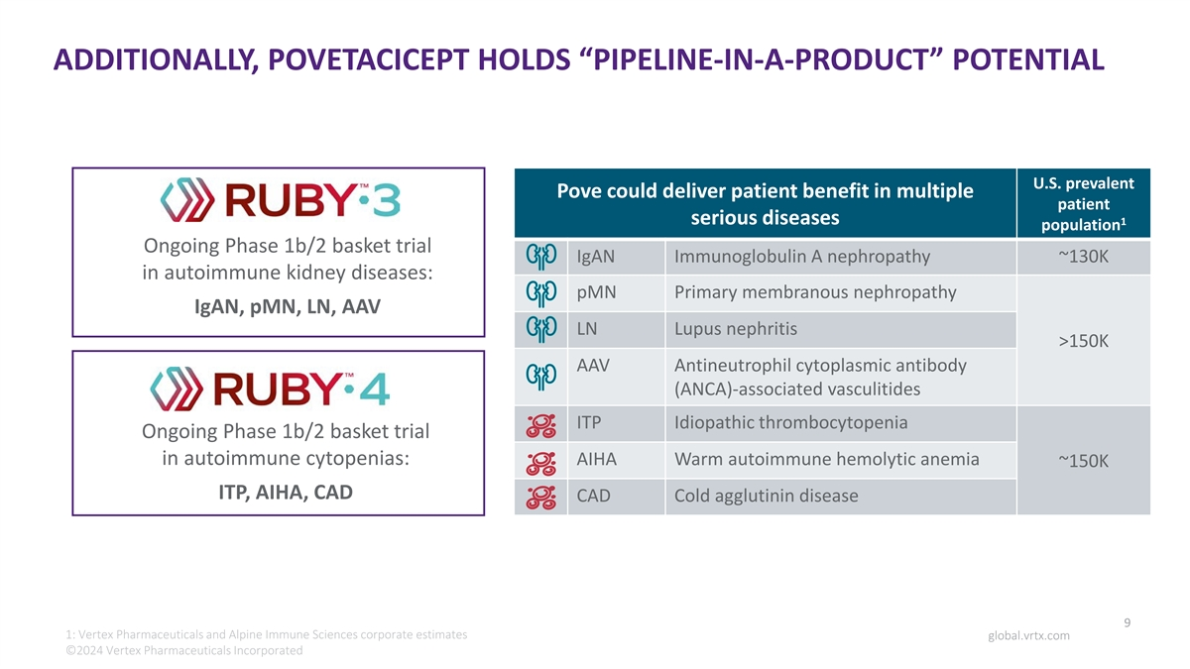
ADDITIONALLY, POVETACICEPT HOLDS “PIPELINE-IN-A-PRODUCT” POTENTIAL U.S. prevalent Pove could deliver patient benefit in multiple patient serious diseases 1 population Ongoing Phase 1b/2 basket trial IgAN Immunoglobulin A nephropathy ~130K in autoimmune kidney diseases: pMN Primary membranous nephropathy IgAN, pMN, LN, AAV LN Lupus nephritis >150K AAV Antineutrophil cytoplasmic antibody (ANCA)-associated vasculitides ITP Idiopathic thrombocytopenia Ongoing Phase 1b/2 basket trial in autoimmune cytopenias: AIHA Warm autoimmune hemolytic anemia ~150K ITP, AIHA, CAD CAD Cold agglutinin disease 9 1: Vertex Pharmaceuticals and Alpine Immune Sciences corporate estimates global.vrtx.com ©2024 Vertex Pharmaceuticals Incorporated

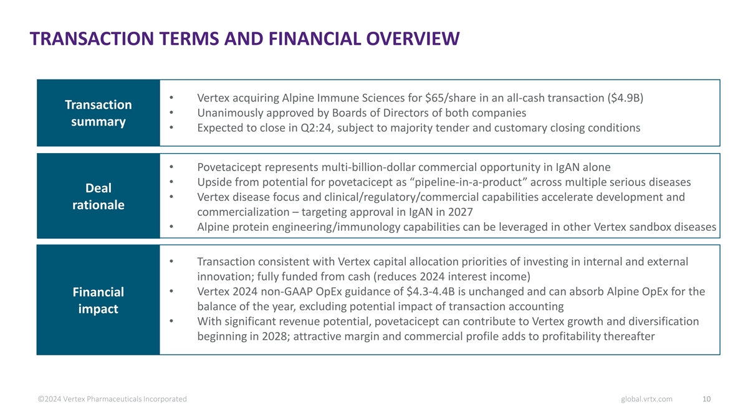
TRANSACTION TERMS AND FINANCIAL OVERVIEW • Vertex acquiring Alpine Immune Sciences for $65/share in an all-cash transaction ($4.9B) Transaction • Unanimously approved by Boards of Directors of both companies summary • Expected to close in Q2:24, subject to majority tender and customary closing conditions • Povetacicept represents multi-billion-dollar commercial opportunity in IgAN alone • Upside from potential for povetacicept as “pipeline-in-a-product” across multiple serious diseases Deal • Vertex disease focus and clinical/regulatory/commercial capabilities accelerate development and rationale commercialization – targeting approval in IgAN in 2027 • Alpine protein engineering/immunology capabilities can be leveraged in other Vertex sandbox diseases • Transaction consistent with Vertex capital allocation priorities of investing in internal and external innovation; fully funded from cash (reduces 2024 interest income) • Vertex 2024 non-GAAP OpEx guidance of $4.3-4.4B is unchanged and can absorb Alpine OpEx for the Financial balance of the year, excluding potential impact of transaction accounting impact • With significant revenue potential, povetacicept can contribute to Vertex growth and diversification beginning in 2028; attractive margin and commercial profile adds to profitability thereafter ©2024 Vertex Pharmaceuticals Incorporated global.vrtx.com 10

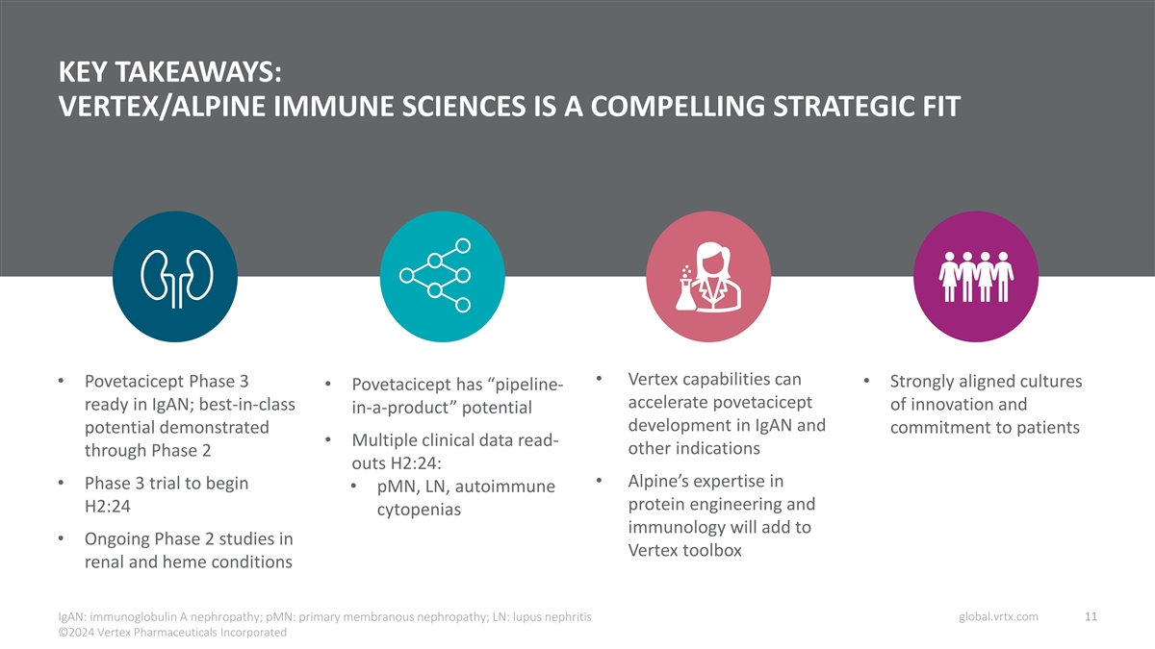
KEY TAKEAWAYS: VERTEX/ALPINE IMMUNE SCIENCES IS A COMPELLING STRATEGIC FIT • Vertex capabilities can • Povetacicept Phase 3 • Strongly aligned cultures • Povetacicept has “pipeline- accelerate povetacicept ready in IgAN; best-in-class of innovation and in-a-product” potential development in IgAN and potential demonstrated commitment to patients • Multiple clinical data read- other indications through Phase 2 outs H2:24: • Alpine’s expertise in • Phase 3 trial to begin • pMN, LN, autoimmune protein engineering and H2:24 cytopenias immunology will add to • Ongoing Phase 2 studies in Vertex toolbox renal and heme conditions global.vrtx.com 11 IgAN: immunoglobulin A nephropathy; pMN: primary membranous nephropathy; LN: lupus nephritis ©2024 Vertex Pharmaceuticals Incorporated


VERTEX PHARMACEUTICALS APRIL 10, 2024 ©2024 Vertex Phag rlm oba acle .v uti rtx c.a clo s m Incorporated

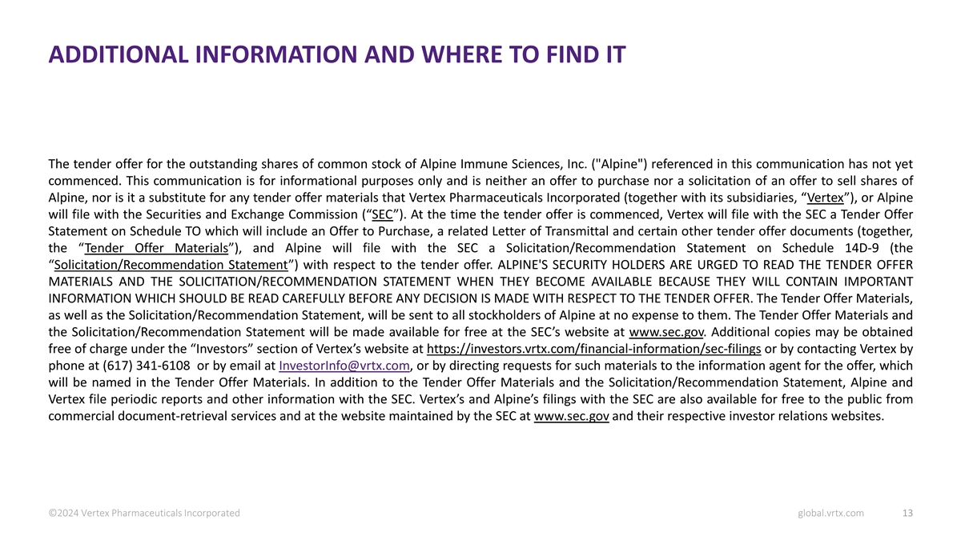
ADDITIONAL INFORMATION AND WHERE TO FIND IT The tender offer for the outstanding shares of common stock of Alpine Immune Sciences, Inc. ( Alpine ) referenced in this communication has not yet commenced. This communication is for informational purposes only and is neither an offer to purchase nor a solicitation of an offer to sell shares of Alpine, nor is it a substitute for any tender offer materials that Vertex Pharmaceuticals Incorporated (together with its subsidiaries, “Vertex”), or Alpine will file with the Securities and Exchange Commission (“SEC”). At the time the tender offer is commenced, Vertex will file with the SEC a Tender Offer Statement on Schedule TO which will include an Offer to Purchase, a related Letter of Transmittal and certain other tender offer documents (together, the “Tender Offer Materials”), and Alpine will file with the SEC a Solicitation/Recommendation Statement on Schedule 14D-9 (the “Solicitation/Recommendation Statement”) with respect to the tender offer. ALPINE'S SECURITY HOLDERS ARE URGED TO READ THE TENDER OFFER MATERIALS AND THE SOLICITATION/RECOMMENDATION STATEMENT WHEN THEY BECOME AVAILABLE BECAUSE THEY WILL CONTAIN IMPORTANT INFORMATION WHICH SHOULD BE READ CAREFULLY BEFORE ANY DECISION IS MADE WITH RESPECT TO THE TENDER OFFER. The Tender Offer Materials, as well as the Solicitation/Recommendation Statement, will be sent to all stockholders of Alpine at no expense to them. The Tender Offer Materials and the Solicitation/Recommendation Statement will be made available for free at the SEC’s website at www.sec.gov. Additional copies may be obtained free of charge under the “Investors” section of Vertex’s website at https://investors.vrtx.com/financial-information/sec-filings or by contacting Vertex by phone at (617) 341-6108 or by email at InvestorInfo@vrtx.com, or by directing requests for such materials to the information agent for the offer, which will be named in the Tender Offer Materials. In addition to the Tender Offer Materials and the Solicitation/Recommendation Statement, Alpine and Vertex file periodic reports and other information with the SEC. Vertex’s and Alpine’s filings with the SEC are also available for free to the public from commercial document-retrieval services and at the website maintained by the SEC at www.sec.gov and their respective investor relations websites. ©2024 Vertex Pharmaceuticals Incorporated global.vrtx.com 13

